**5.AWS-VPC-TransitGateway & Egress Gateway**

**Transit Gateway Creating**

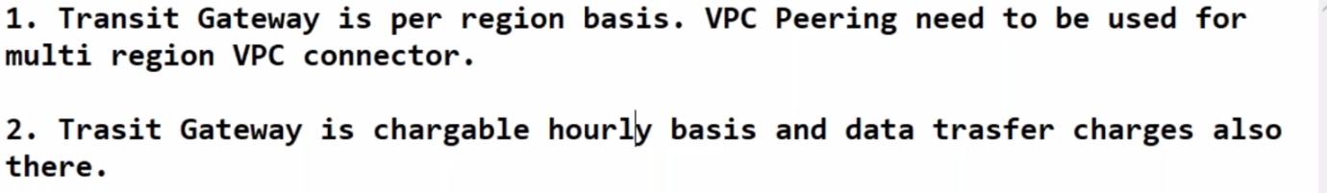 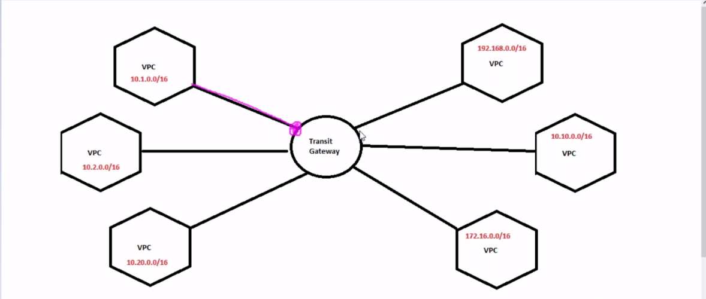

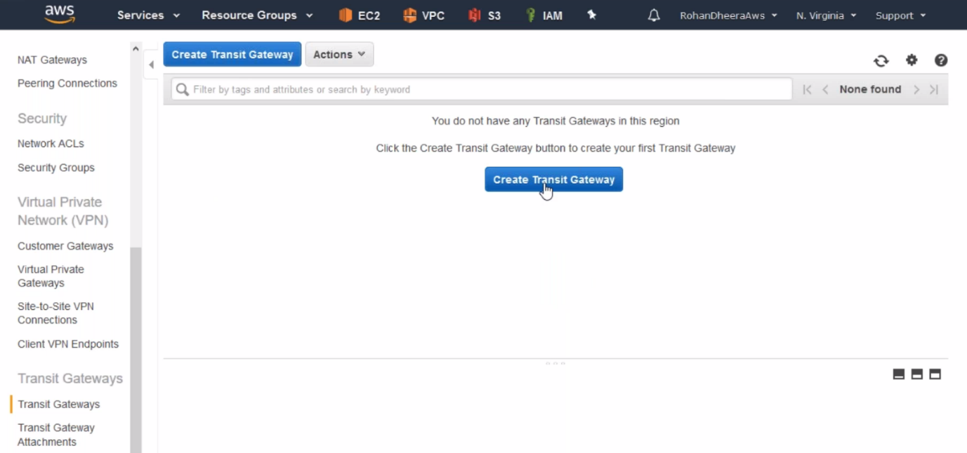

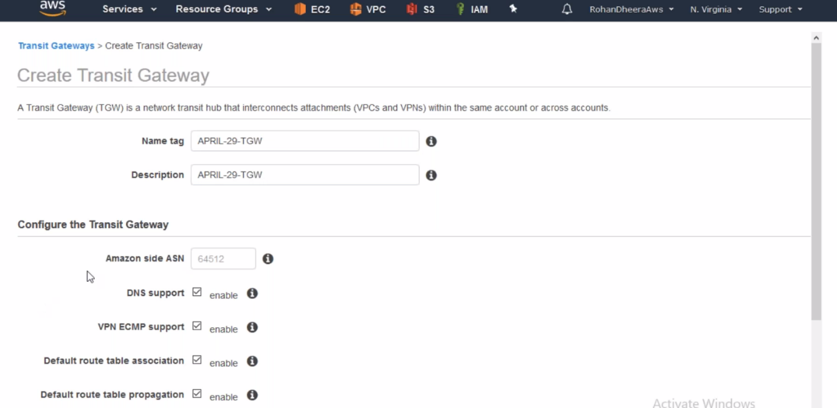

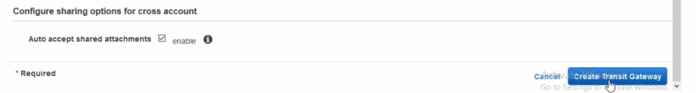

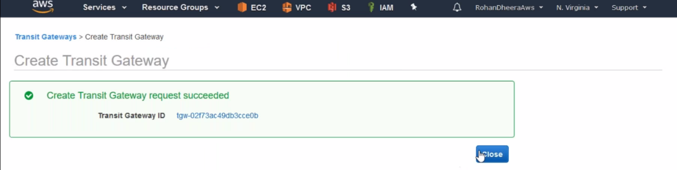

--- transit gate way created successfully.

**Transit Gateway Attachment**

--- we need to attach this transit gate way

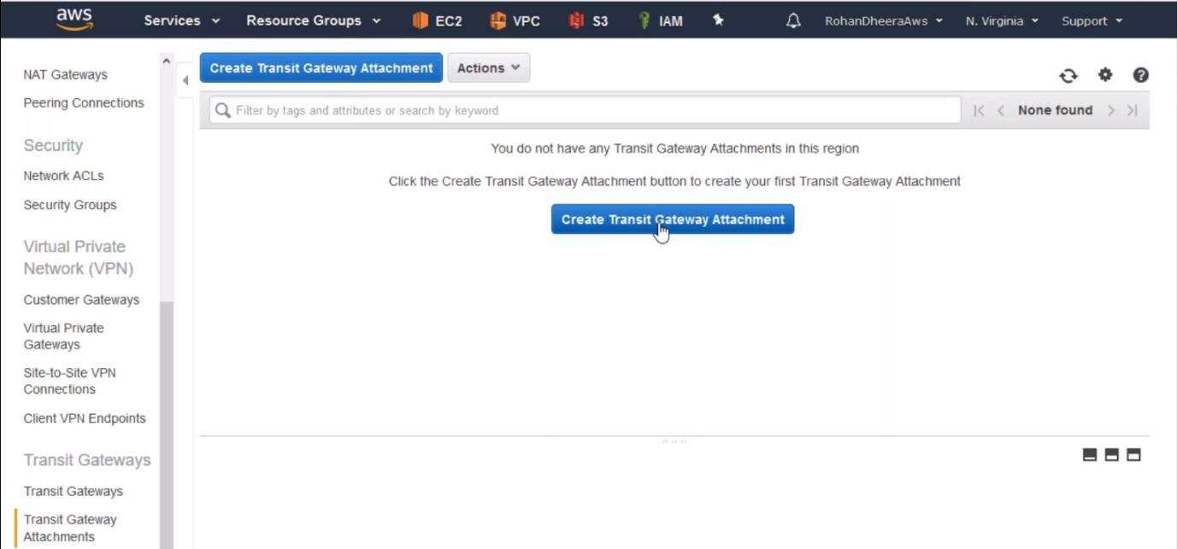

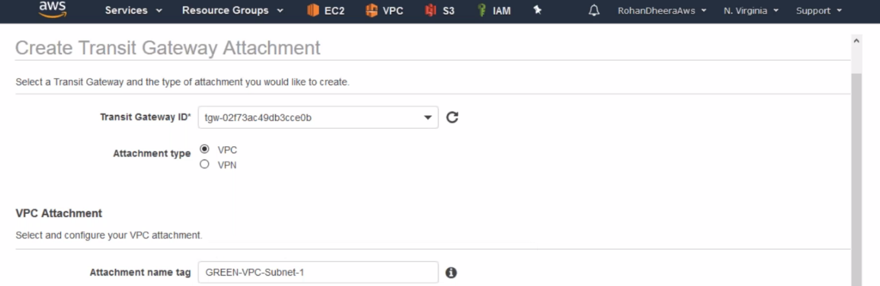

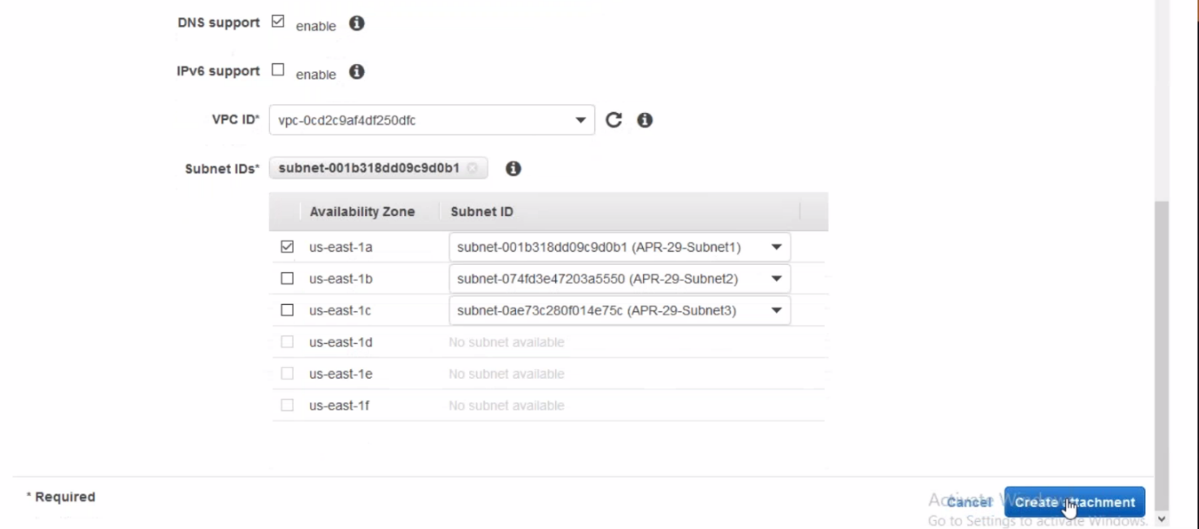

--- same like above create another 2 attachments.

--- **QUES When we create transit gate way…?**

If we have a greater number of VPC’s and you want to create peering between the VPC’s. in this case we use transit gate way.

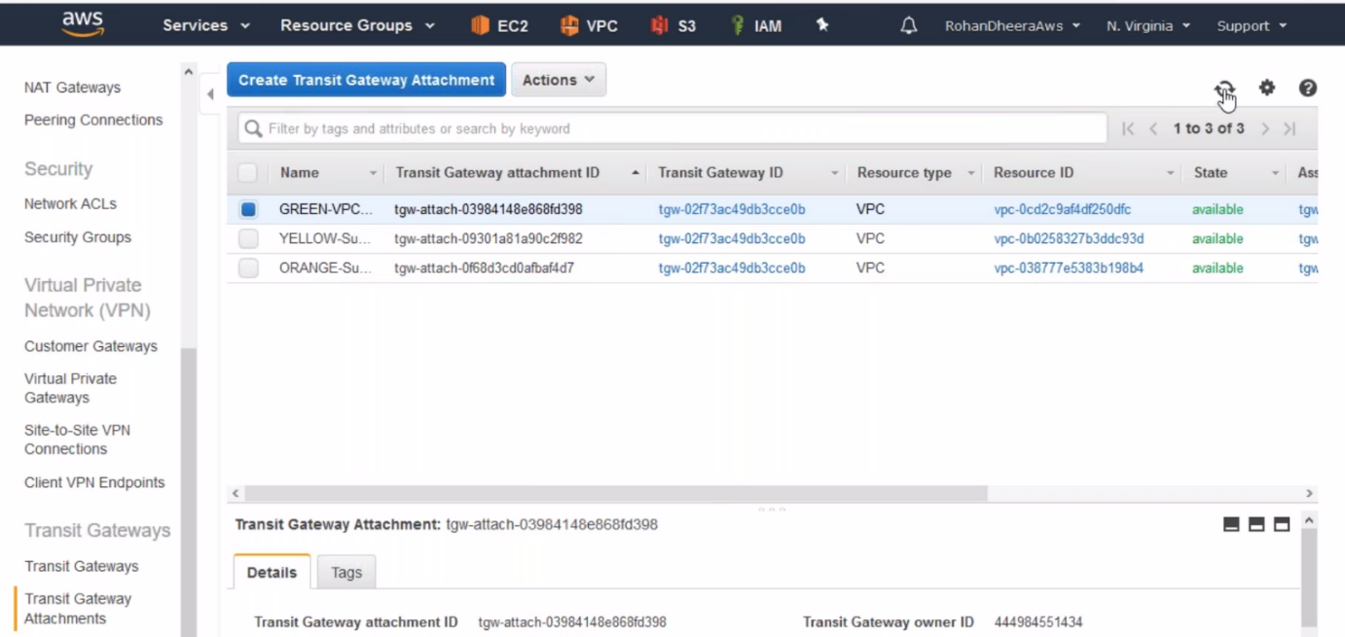

**Routing table for peering connection**

we need to add transit gate way peering connection in the routing table.

Green routing table

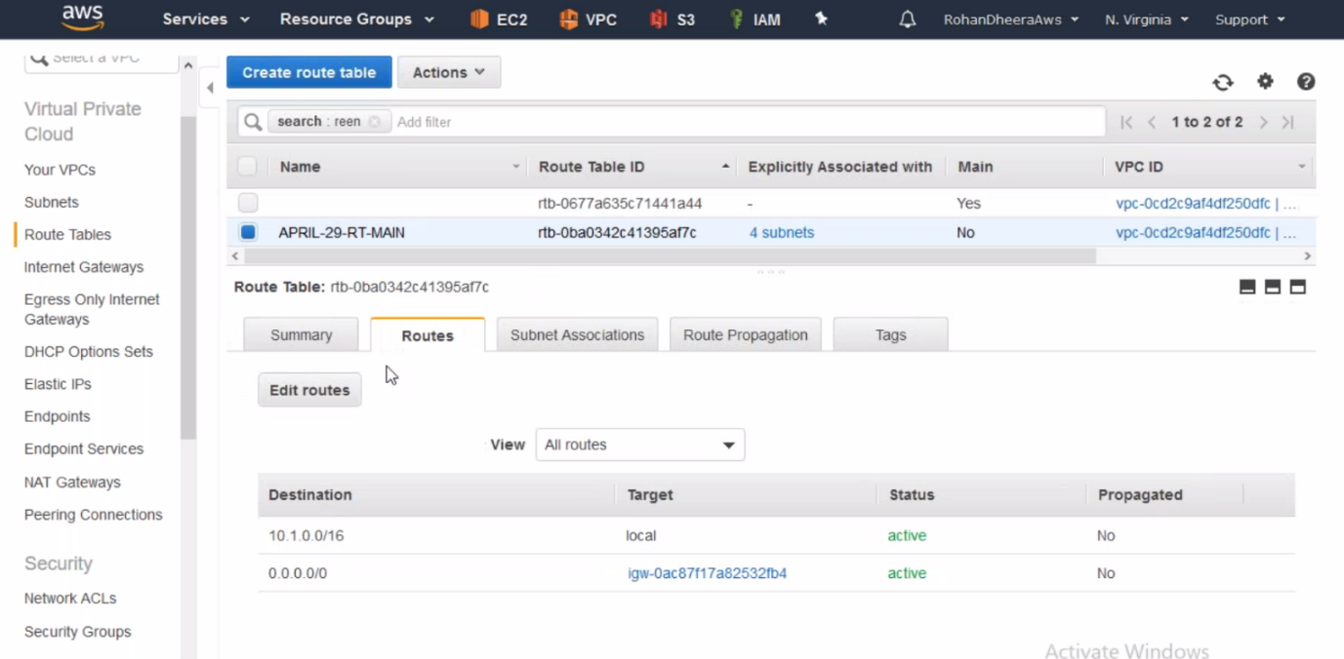

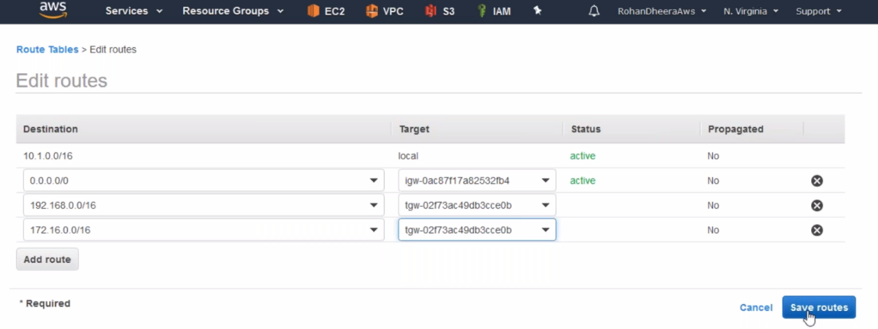

Orange routing table

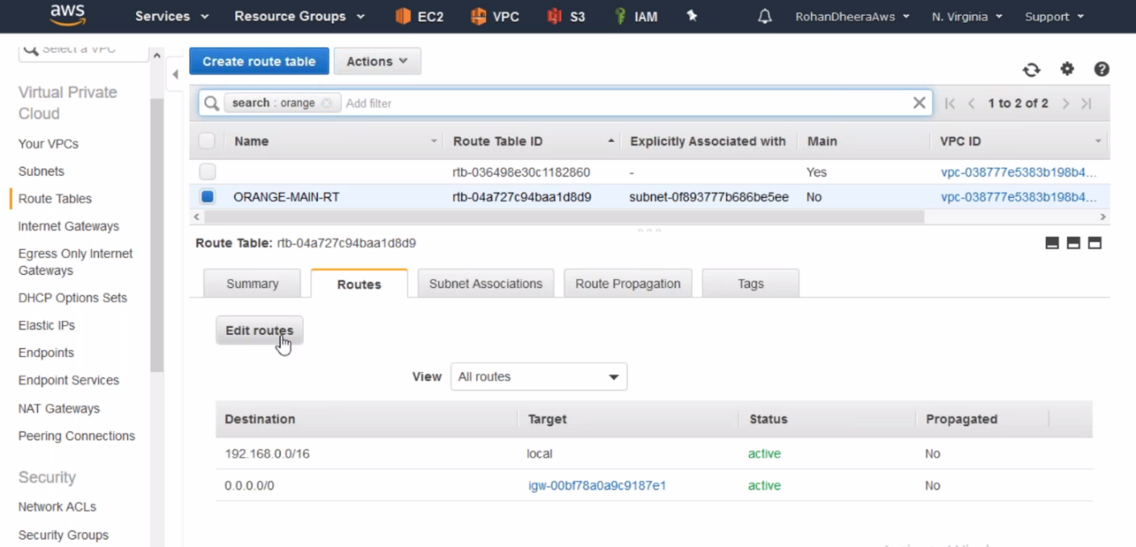

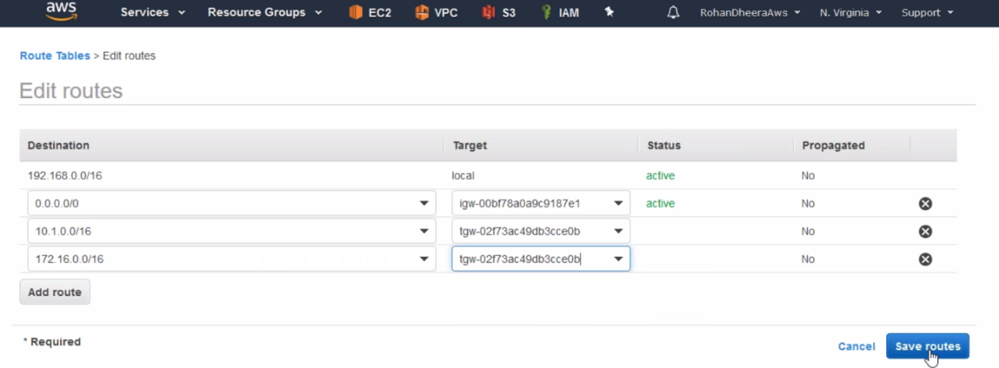

Yellow routing table

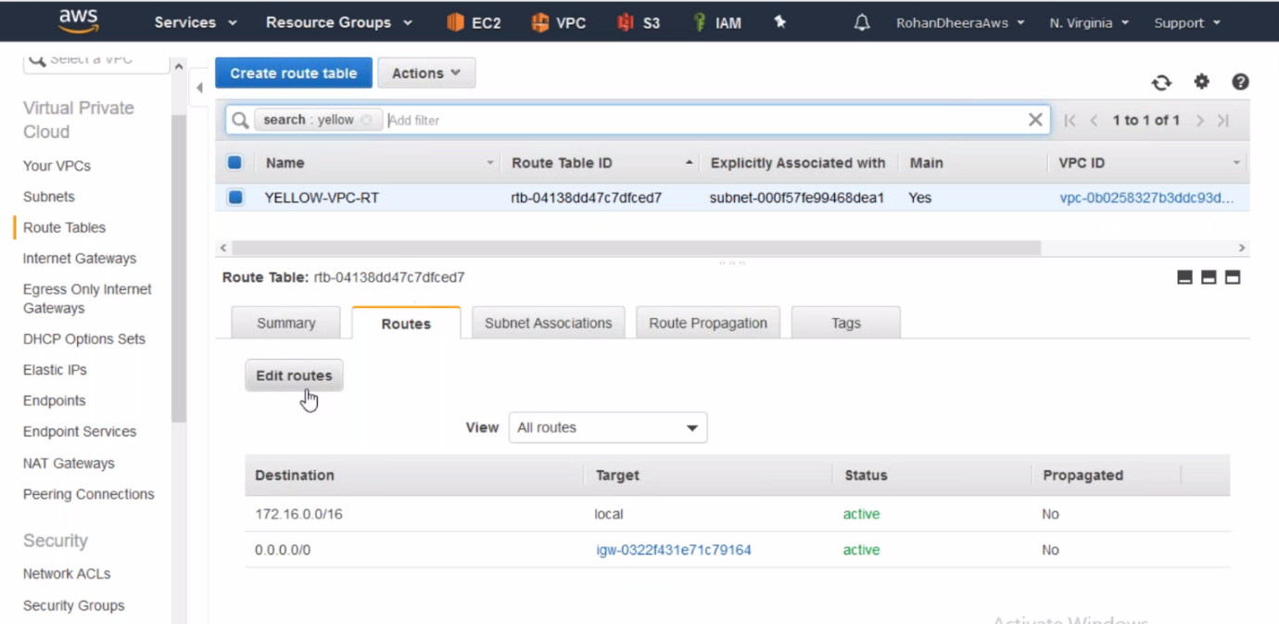

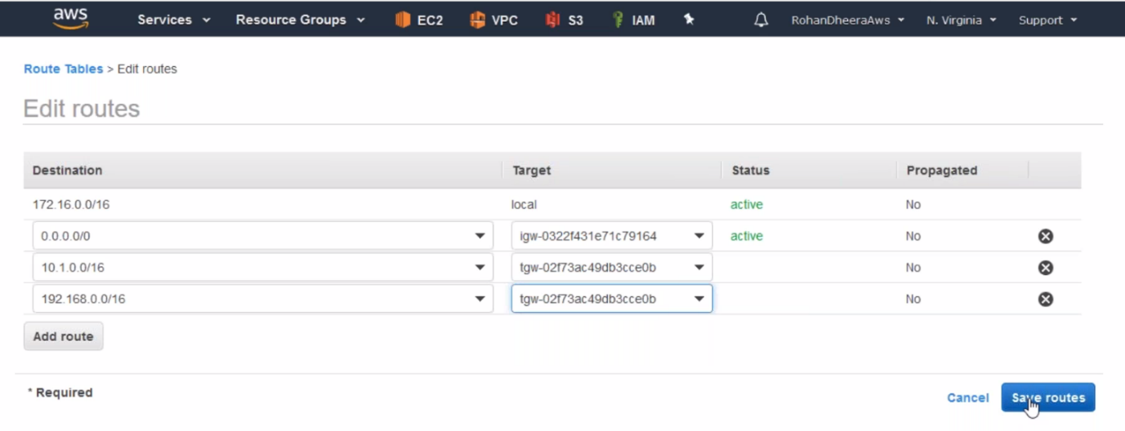

**Transit gate way routing table**

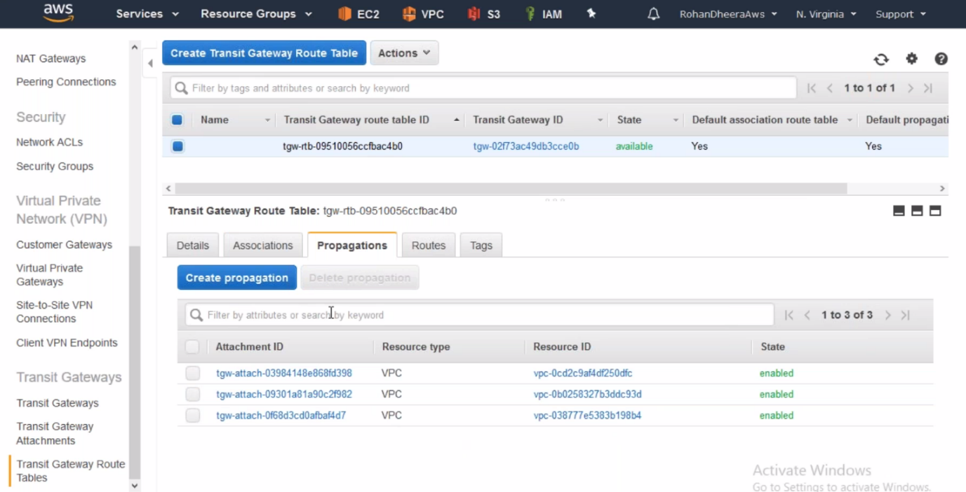

**Egress gate way**

The Egress gate way is used for IPV4

--- Ignore the Egress gate way if you don’t use IPV4. The Egress gate way won’t allow the network from outside to inside.

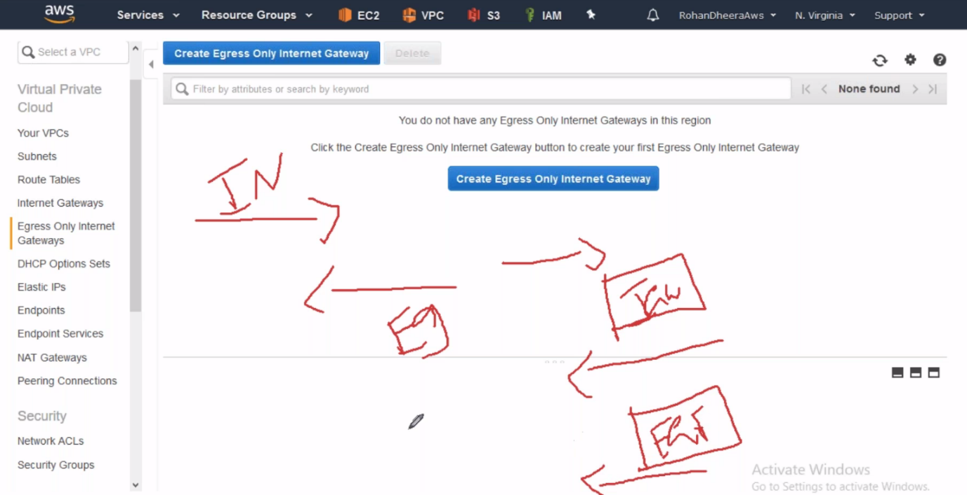

--- ingress – the network from outside to inside

--- Egress – the network from inside to outside